AI/ML Internship — Final Project Report
Titanic Survival Prediction
An end-to-end machine learning classification system with a web application
Next Gen Software Hub — 4-Week AI/ML Internship (Task 4)
Prepared by: [Your Name] Date: [Date]

1. Project Title
Titanic Survival Prediction: an end-to-end classification pipeline with a prediction system and Streamlit web app.

2. Introduction
This project applies the full machine learning workflow covered in the internship: loading and cleaning real data, exploring it, building a reproducible preprocessing pipeline, training and tuning several models, evaluating them honestly, and delivering a working prediction interface. The Titanic passenger dataset was chosen because it is small, well documented, and has clear interpretable relationships, which makes it suitable for learning good practice rather than chasing a leaderboard score.

3. Problem Statement
Given a passenger's ticket class, sex, age, number of siblings/spouses and parents/children aboard, ticket fare and port of embarkation, predict whether the passenger survived the sinking of the Titanic. This is a binary classification problem.

4. Objectives
- Collect and clean a real-world dataset and document every cleaning decision.
- Explore the data to understand which factors relate to survival.
- Build a preprocessing and feature-engineering pipeline that avoids data leakage.
- Train, tune and compare at least three models using cross-validation.
- Evaluate the selected model on a held-out test set using accuracy, precision, recall, F1, ROC-AUC and a confusion matrix.
- Deliver a prediction system (command line and Streamlit web app) that accepts raw passenger details.

5. Technologies Used
Tool | Purpose
Python 3 | Programming language
pandas, NumPy | Data loading, cleaning and numerical work
Matplotlib, Seaborn | Charts and visualisation
scikit-learn | Pipelines, preprocessing, models, GridSearchCV, metrics
joblib | Saving and loading the trained model
Streamlit | Web user interface for the prediction system
Jupyter Notebook | Interactive analysis and documentation

6. Dataset Description
Source: the Titanic dataset from the seaborn-data repository (https://github.com/mwaskom/seaborn-data), stored as data/titanic_raw.csv. It contains 891 passenger records and 15 columns. Seven input columns and the target are used:
Column | Meaning | Type | Missing
pclass | Ticket class (1 = first, 3 = third) | Integer | 0
sex | Passenger sex | Categorical | 0
age | Age in years | Numeric | 177 (19.9%)
sibsp | Siblings / spouses aboard | Integer | 0
parch | Parents / children aboard | Integer | 0
fare | Ticket fare | Numeric | 0
embarked | Port: S, C or Q | Categorical | 2
survived | Target: 1 = survived, 0 = died | Binary | 0

The remaining columns (class, who, adult_male, deck, embark_town, alive, alone) either repeat these fields or the target, or are mostly empty (deck is 77.2% missing), so they were excluded. After cleaning, 41.3% of the 780 passengers survived, so a model that always predicts "died" would be right about 58.7% of the time; this is the baseline to beat.

7. Data Preprocessing

Cleaning
- Removed 111 duplicate records (891 to 780 rows). The dataset has no passenger ID, so identical rows might be different people; this is noted as a limitation.
- Dropped deck and the redundant columns.
- Kept fare outliers, because very high fares are real first-class tickets, and reduced their effect with a log transform (fare skewness fell from 4.56 to 0.45).

Pipeline (no data leakage)
Missing values are not filled before splitting the data. Instead, one scikit-learn pipeline performs all steps and learns its statistics from the training data only:
- Numeric features (age, sibsp, parch, family_size, fare_log): median imputation, then standard scaling.
- Categorical features (pclass, sex, embarked): most-frequent imputation, then one-hot encoding.
- Engineered features: family_size = sibsp + parch + 1, is_alone, and fare_log = log(1 + fare).
Because the same saved pipeline is used by the app, a user can enter raw values and the identical preprocessing is applied automatically, even when age is unknown.

8. Exploratory Data Analysis
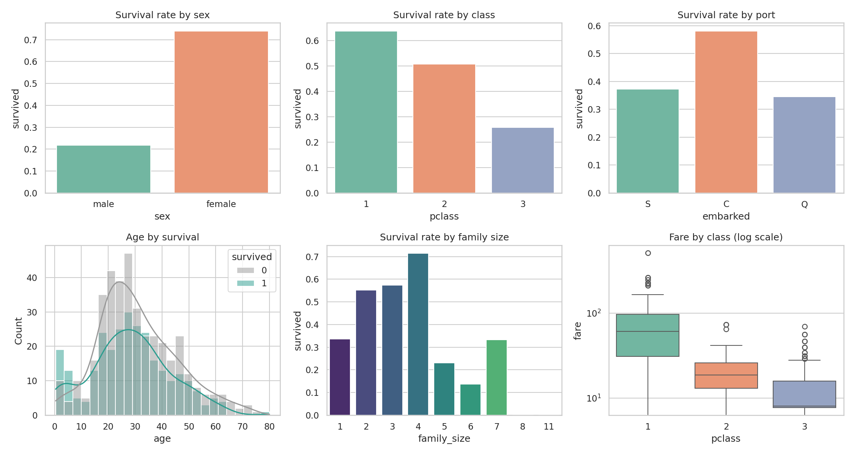
Figure 1. Survival by sex, class, port, age, family size and fare by class.
- Sex and class dominate. Survival was 96.8% for first-class women and 91.7% for second-class women, but only 18.5% for second-class men and 15.9% for third-class men. Third-class women survived at 47.2%.
- Family size is non-linear. Passengers travelling alone survived less often than small families, while very large families did poorly.
- Fares are strongly right-skewed and rise sharply with class, which motivates the log transform.
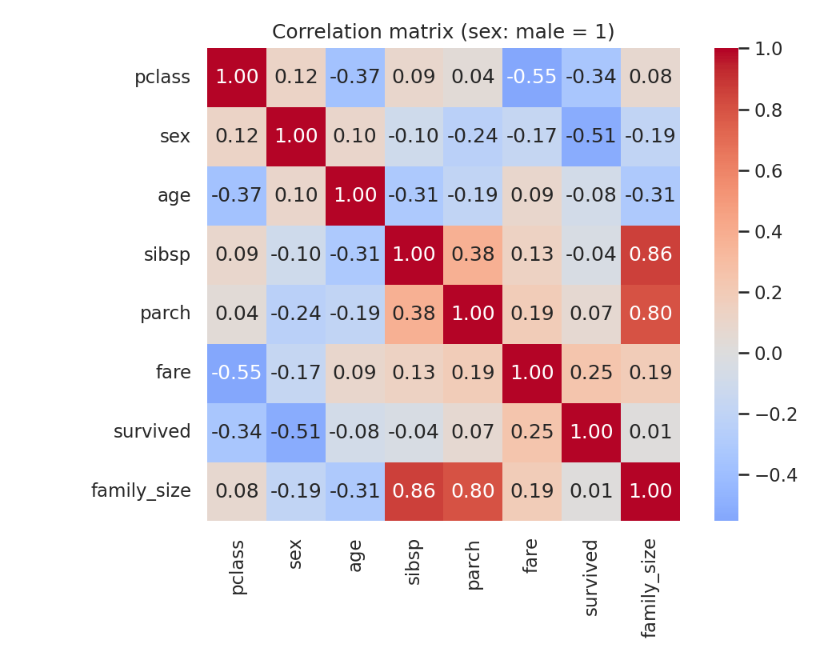
Figure 2. Correlation matrix (sex coded male = 1).

9. Model Development
The data was split 80/20 with stratification (624 training and 156 test passengers) using a fixed random seed. Three models were tuned with 5-fold cross-validated grid search on the training set only, scored by ROC-AUC. The final model was chosen from these cross-validation scores; the test set was not used for selection.
Model | Best hyperparameters | CV ROC-AUC | Selected
Logistic Regression | C = 0.1 | 0.831
Random Forest | n_estimators = 400, max_depth = 8, min_samples_leaf = 5 | 0.845
Gradient Boosting | n_estimators = 100, learning_rate = 0.1, max_depth = 2 | 0.854 | Yes

Gradient Boosting had the highest cross-validated ROC-AUC and was selected. For the deployed model, the same tuned settings were refit on all 780 passengers; the test-set figures below come from the version trained on the training split only, so they remain an honest estimate.

10. Model Evaluation
Model (test set, 156 passengers) | Accuracy | Precision | Recall | F1 | ROC-AUC
Logistic Regression | 0.795 | 0.742 | 0.766 | 0.754 | 0.878
Random Forest | 0.808 | 0.870 | 0.625 | 0.727 | 0.862
Gradient Boosting (selected) | 0.821 | 0.860 | 0.672 | 0.754 | 0.881

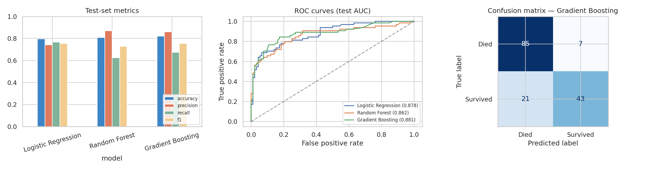
Figure 3. Test-set metrics, ROC curves and the confusion matrix of the selected model.
Confusion matrix of the selected model: 85 true negatives, 7 false positives, 21 false negatives and 43 true positives. The test set is small, so the differences between the three models (about 1-3 passengers' worth of accuracy) should not be over-interpreted; all three are clearly better than the 58.7% baseline.

11. Results
The selected Gradient Boosting model achieved 82.1% test accuracy and a ROC-AUC of 0.881. It is conservative: when it predicts survival it is right 86% of the time (precision), but it finds only 67% of actual survivors (recall). Of the 21 survivors it missed, 14 were men and 7 were women.
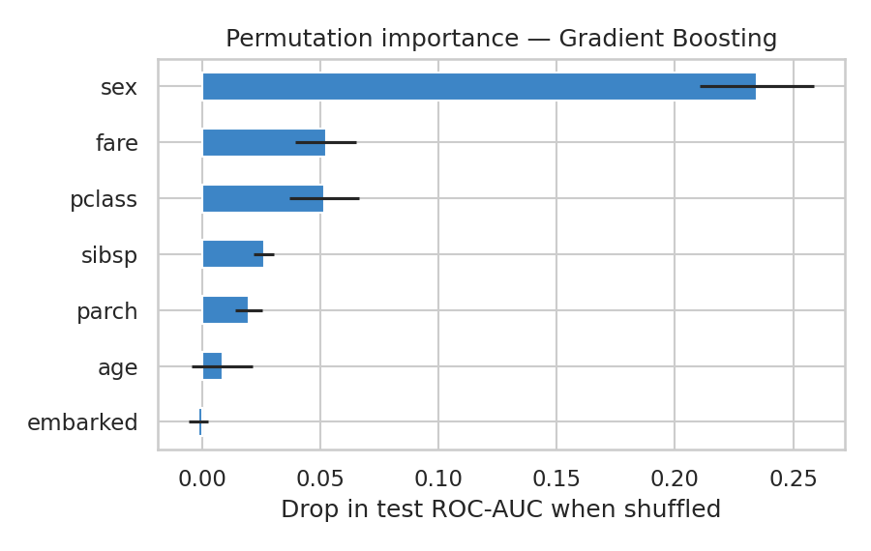
Figure 4. Permutation importance on the test set (drop in ROC-AUC when a feature is shuffled).
Sex is by far the most important input (0.235), followed by fare and ticket class (0.052 each), then siblings/spouses (0.026) and parents/children (0.020). Age (0.008) and port of embarkation (about 0) matter little to this model once the other fields are known, even though children did survive more often in the raw data; this may be because age effects overlap with the family variables. Accuracy by group on the test set was 84.4% for men and 78.3% for women, and 78.0%, 96.7% and 78.9% for first, second and third class (group sizes are small, 30 to 96 passengers).
Example outputs of the prediction system:
Passenger | Prediction | Survival probability
1st-class woman, 29, Cherbourg | Survived | 95.1%
2nd-class boy, 8, with family | Survived | 60.7%
3rd-class woman, 22, large family | Did not survive | 15.6%
3rd-class man, 25, alone | Did not survive | 13.7%
3rd-class man, age unknown | Did not survive | 15.6%

12. Screenshots
The Streamlit app lets a user enter passenger details and shows the predicted outcome with its probability.
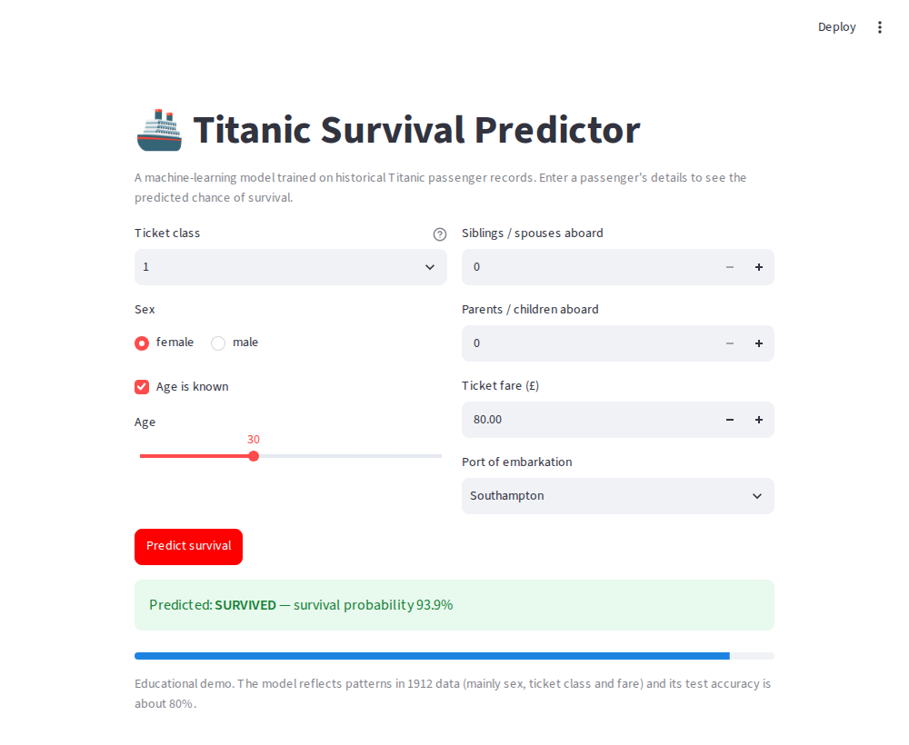
Figure 5. App: first-class woman, fare 80 — predicted to survive (93.9%, age slider at its default of 30).
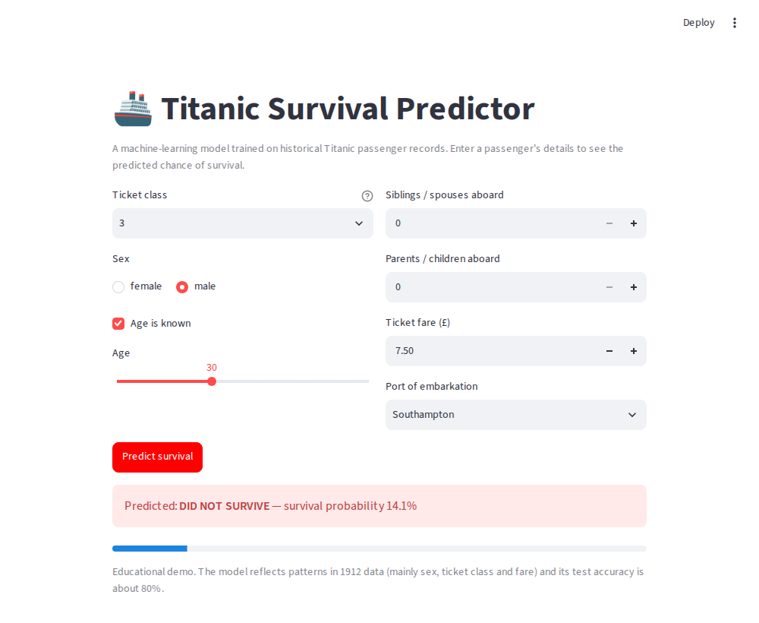
Figure 6. App: third-class man, fare 7.50 — predicted not to survive (14.1%, age at default 30).

13. Challenges Faced
- Avoiding data leakage. Filling missing ages or fitting the scaler on the whole dataset would leak information into the test set. Putting all preprocessing inside one pipeline solved this and also made deployment simple.
- Missing and duplicated data. 20% of ages are missing, and with no passenger ID it is not certain that identical rows are true duplicates.
- Small dataset. With only 156 test passengers, metrics are noisy, so model selection used cross-validation instead of the test set.
- Low recall. The model misses about a third of survivors. A lower decision threshold would raise recall at the cost of precision.
- Inconsistent row counts across weeks. Earlier weekly tasks removed duplicates after filling ages and so ended with 773 rows; this project removes duplicates before imputation, giving 780. Results are therefore close but not identical.

14. Future Improvements
- Extract passenger titles (Mr, Mrs, Miss, Master) from names, which usually improves Titanic models.
- Tune the decision threshold to trade precision against recall, and calibrate probabilities.
- Try more models (SVM, XGBoost/LightGBM) and use repeated cross-validation for more stable comparisons.
- Add model explanations (for example SHAP values) to the app, and input validation for unusual values.
- Deploy the app publicly (Streamlit Community Cloud) and add automated tests.

15. Conclusion
The project delivered a complete, reproducible machine learning workflow, from raw data to a working web application. The selected Gradient Boosting model reaches about 82% test accuracy (ROC-AUC 0.88) against a 58.7% baseline. The analysis shows that survival depended mainly on sex and ticket class, which matches the well-known "women and children first" evacuation pattern and the class differences in access to lifeboats. Practices such as leak-free preprocessing, cross-validated model selection and an honest held-out evaluation matter as much as the model choice, and the same pipeline can be reused for other tabular prediction tasks.

